**ASSIGNMENT-4**

**MODULE-8**

**SQS & SES**

**DONE BY  
RANJITH KUMAR**

**Tasks To Be Performed:**

1. Create a FIFO SQS queue and test by sending messages.

2. Register your mail in SES and send a test mail to yourself.

STEP 1 : Open SQS from aws services

STEP 2 : Select create queue

STEP 3 : Select FIFO , name , configuration of the queue to create the queue

STEP 4 : Queue has been created

STEP 5 : Select the queue and click **Send and receive messages**

STEP 6 : Give message body , group id and deduplication id and click **Send message**

STEP 7 : Then go to Receive message and click poll for messages

STEP 8 : Messages has been received

STEP 9 : Open SES from aws services

STEP 10 : Create an identity by selecting emailid identity details and mention the email

STEP 11 : Mail has been received to the mentioned email for confirmation

STEP 12 : Select the SQS identity and click **Send test mail**

STEP 13 : Select format , from mail address , scenario and additional configuaration and click send test mail

STEP 14 : Mail has been received to the mentioned email

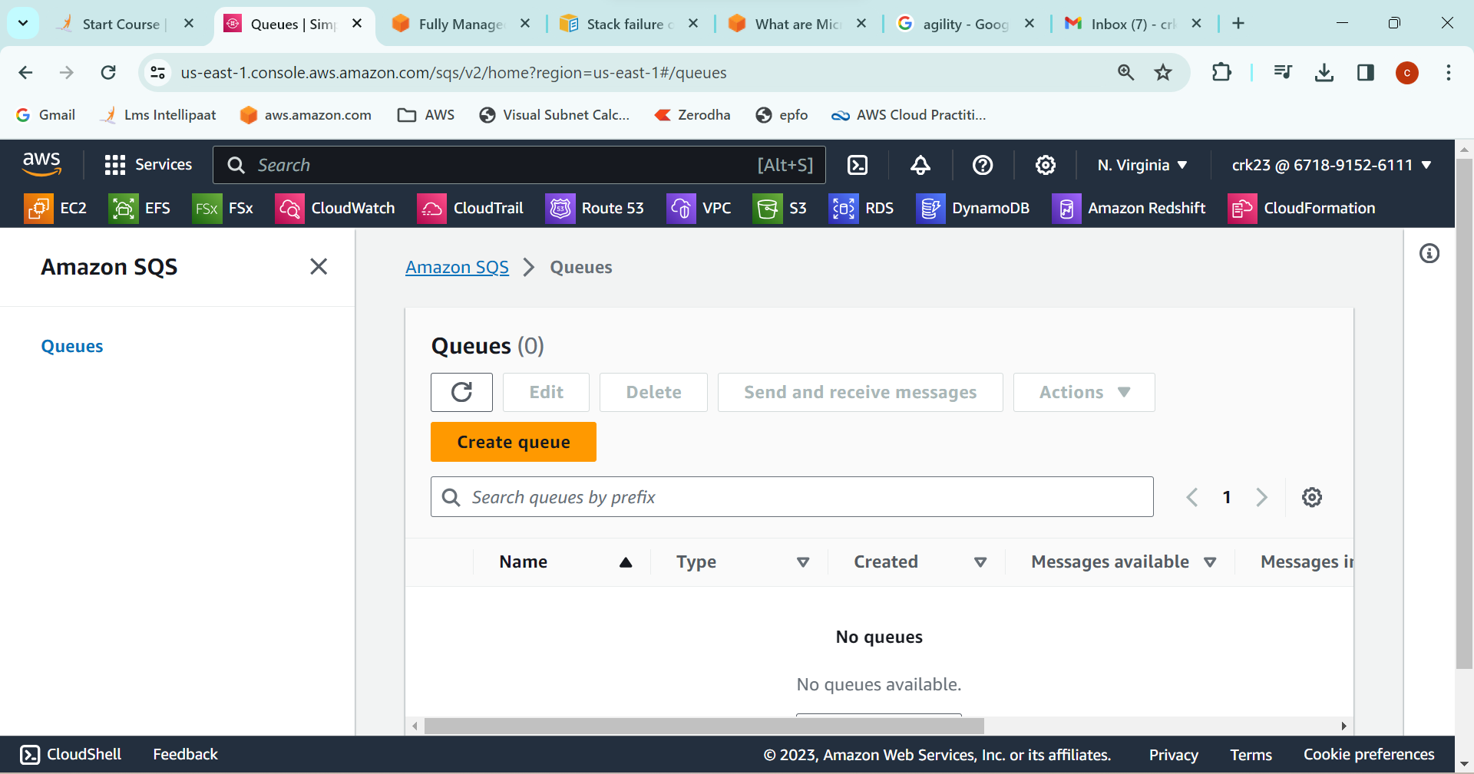

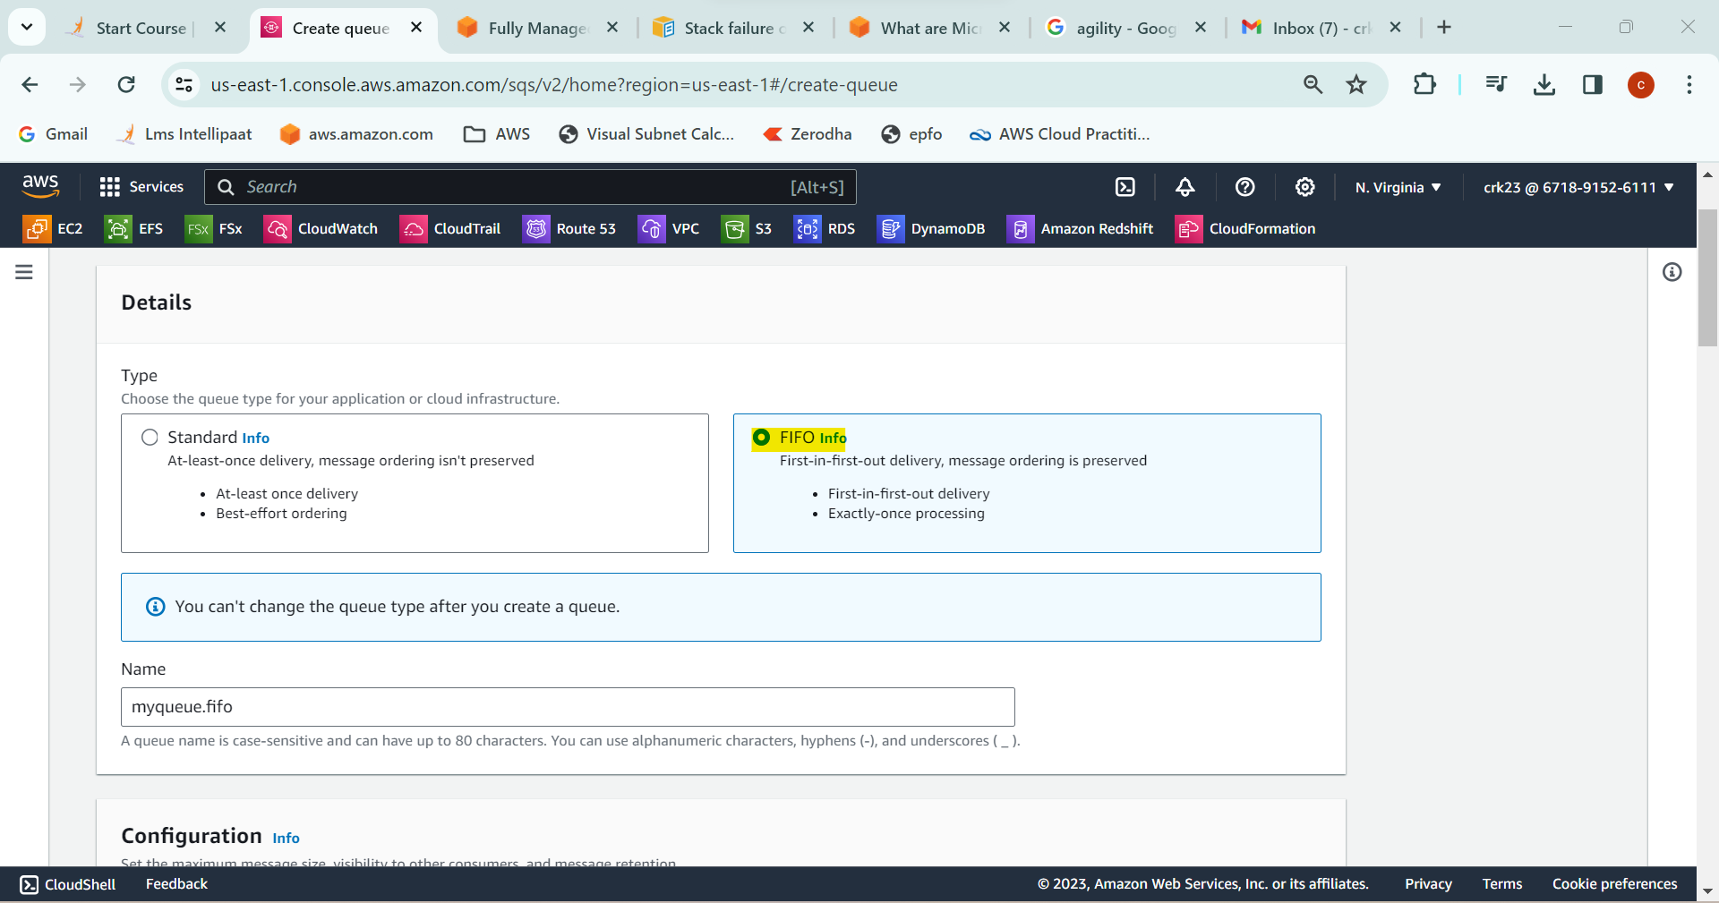

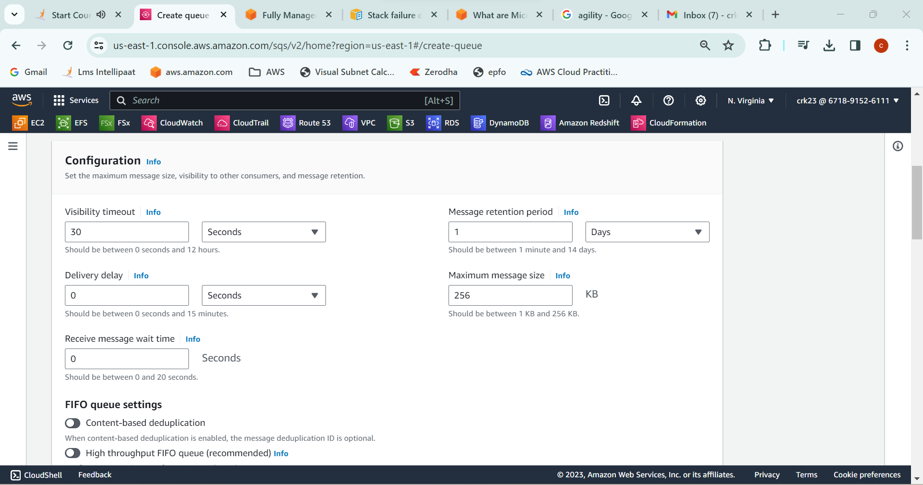

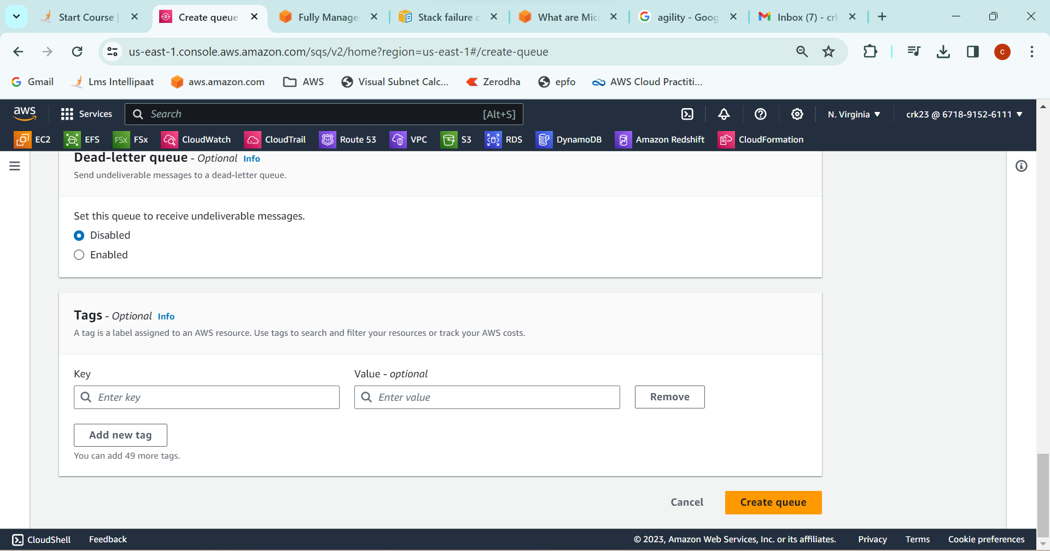

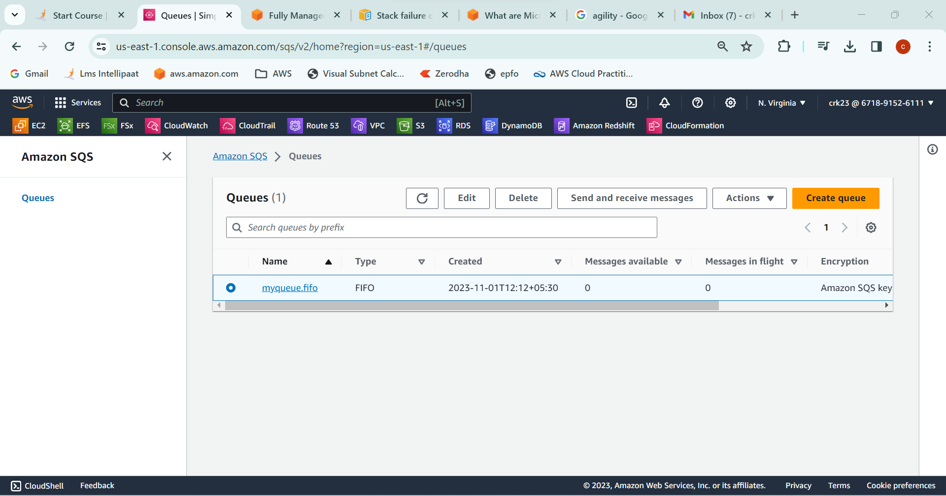

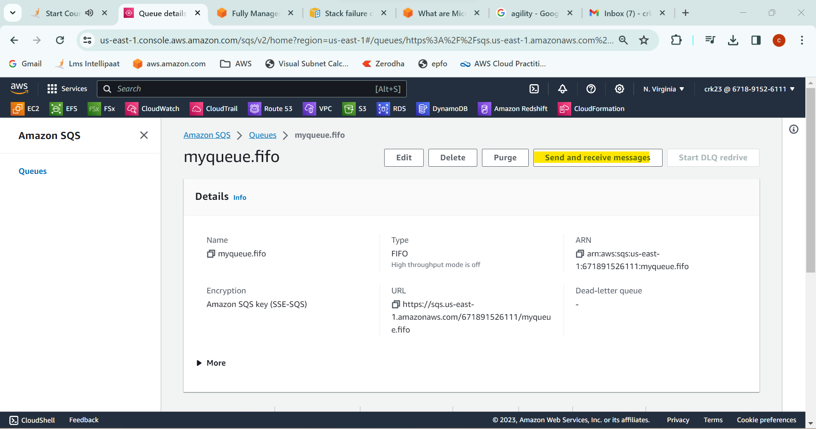

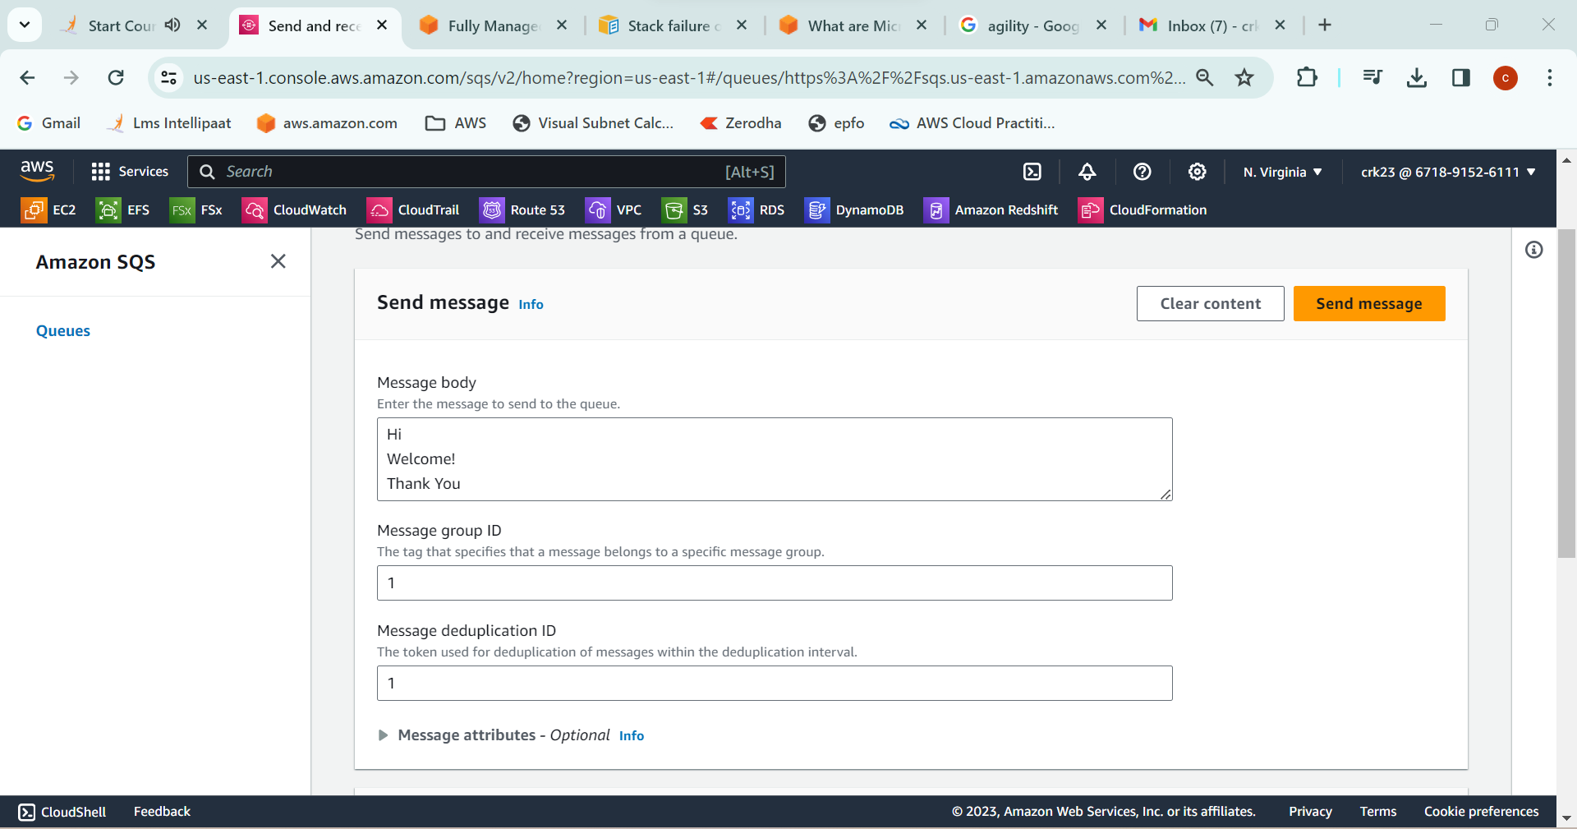

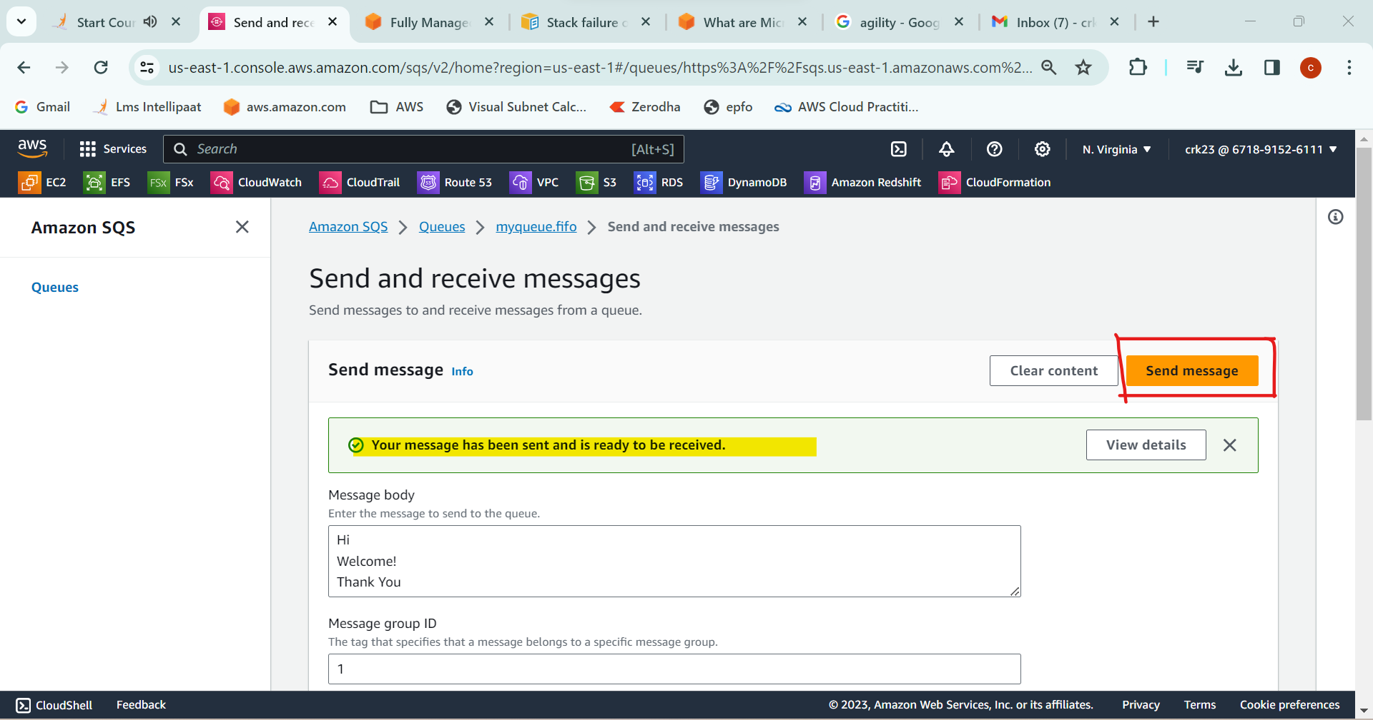

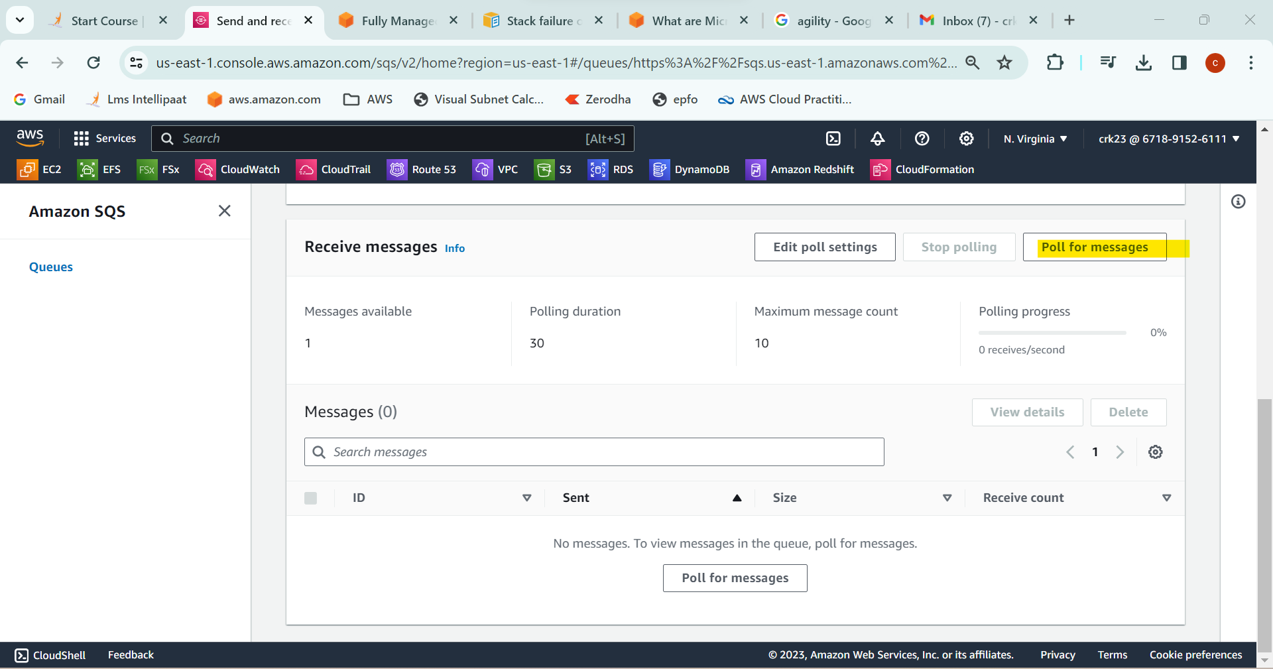

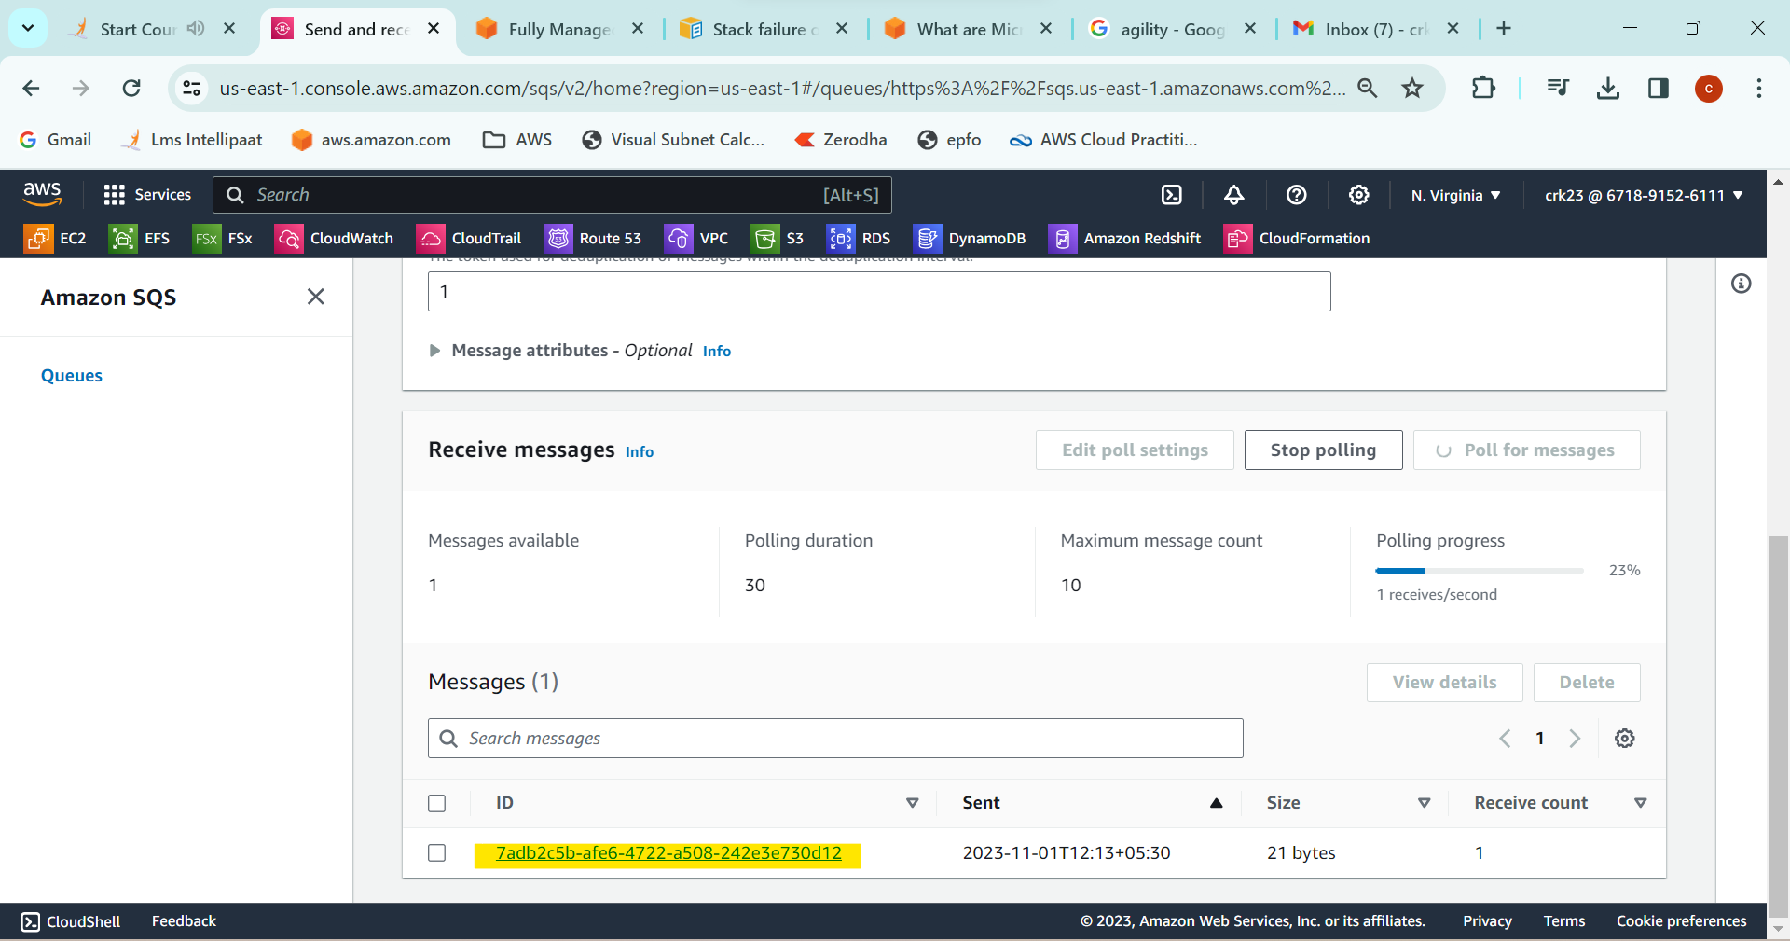

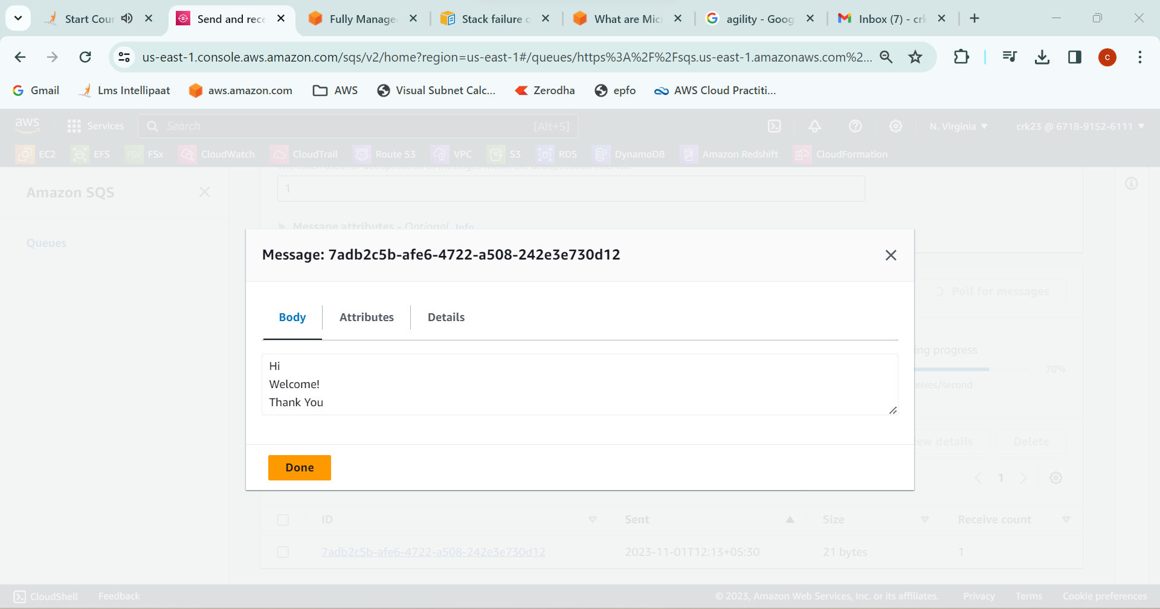

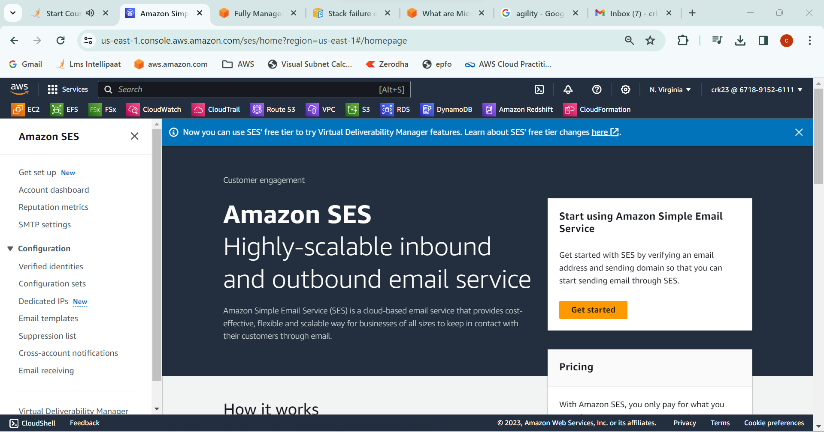

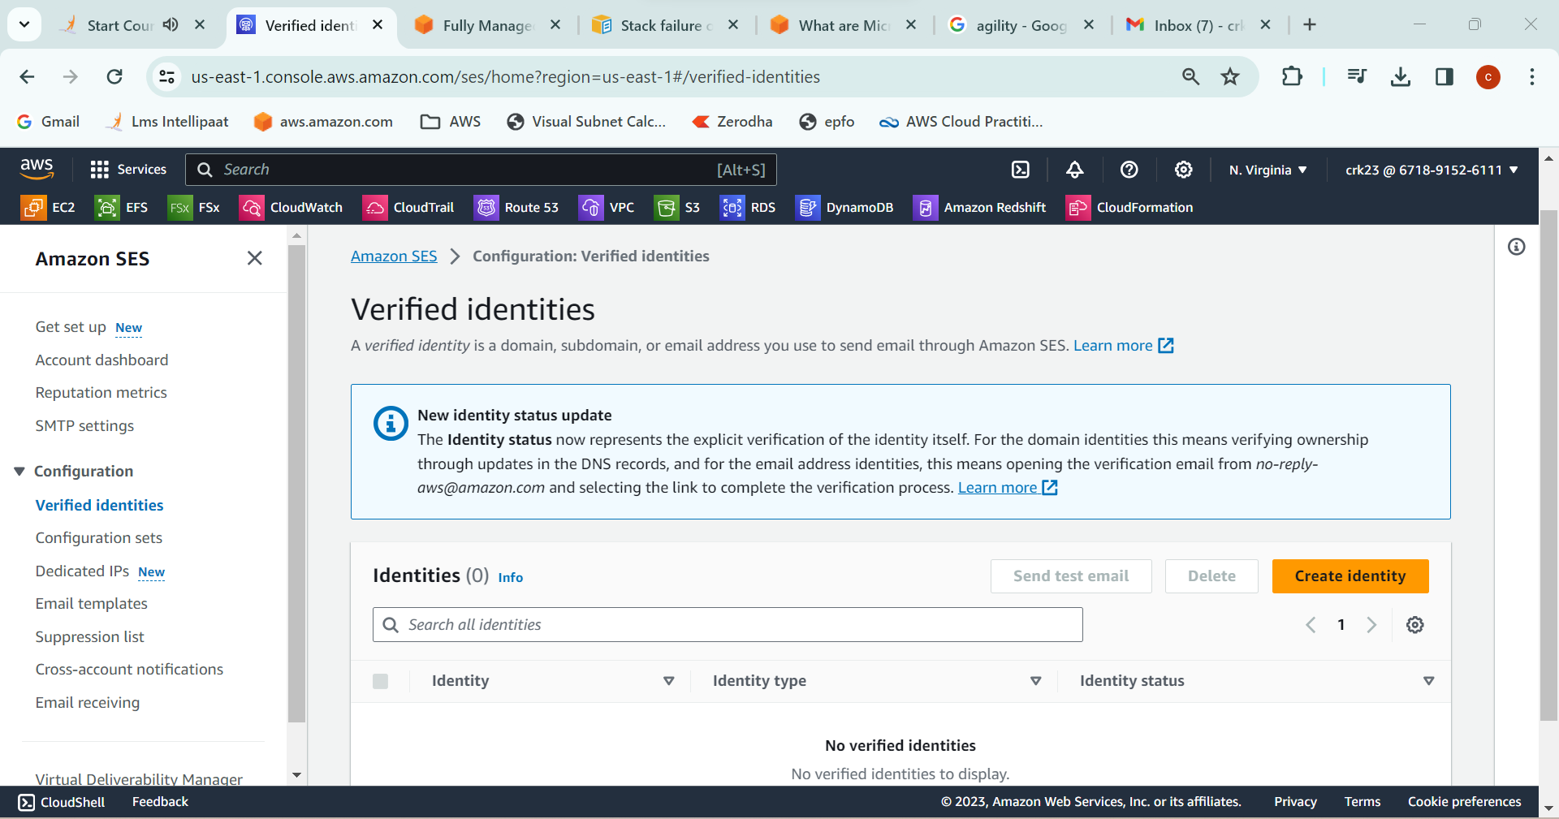

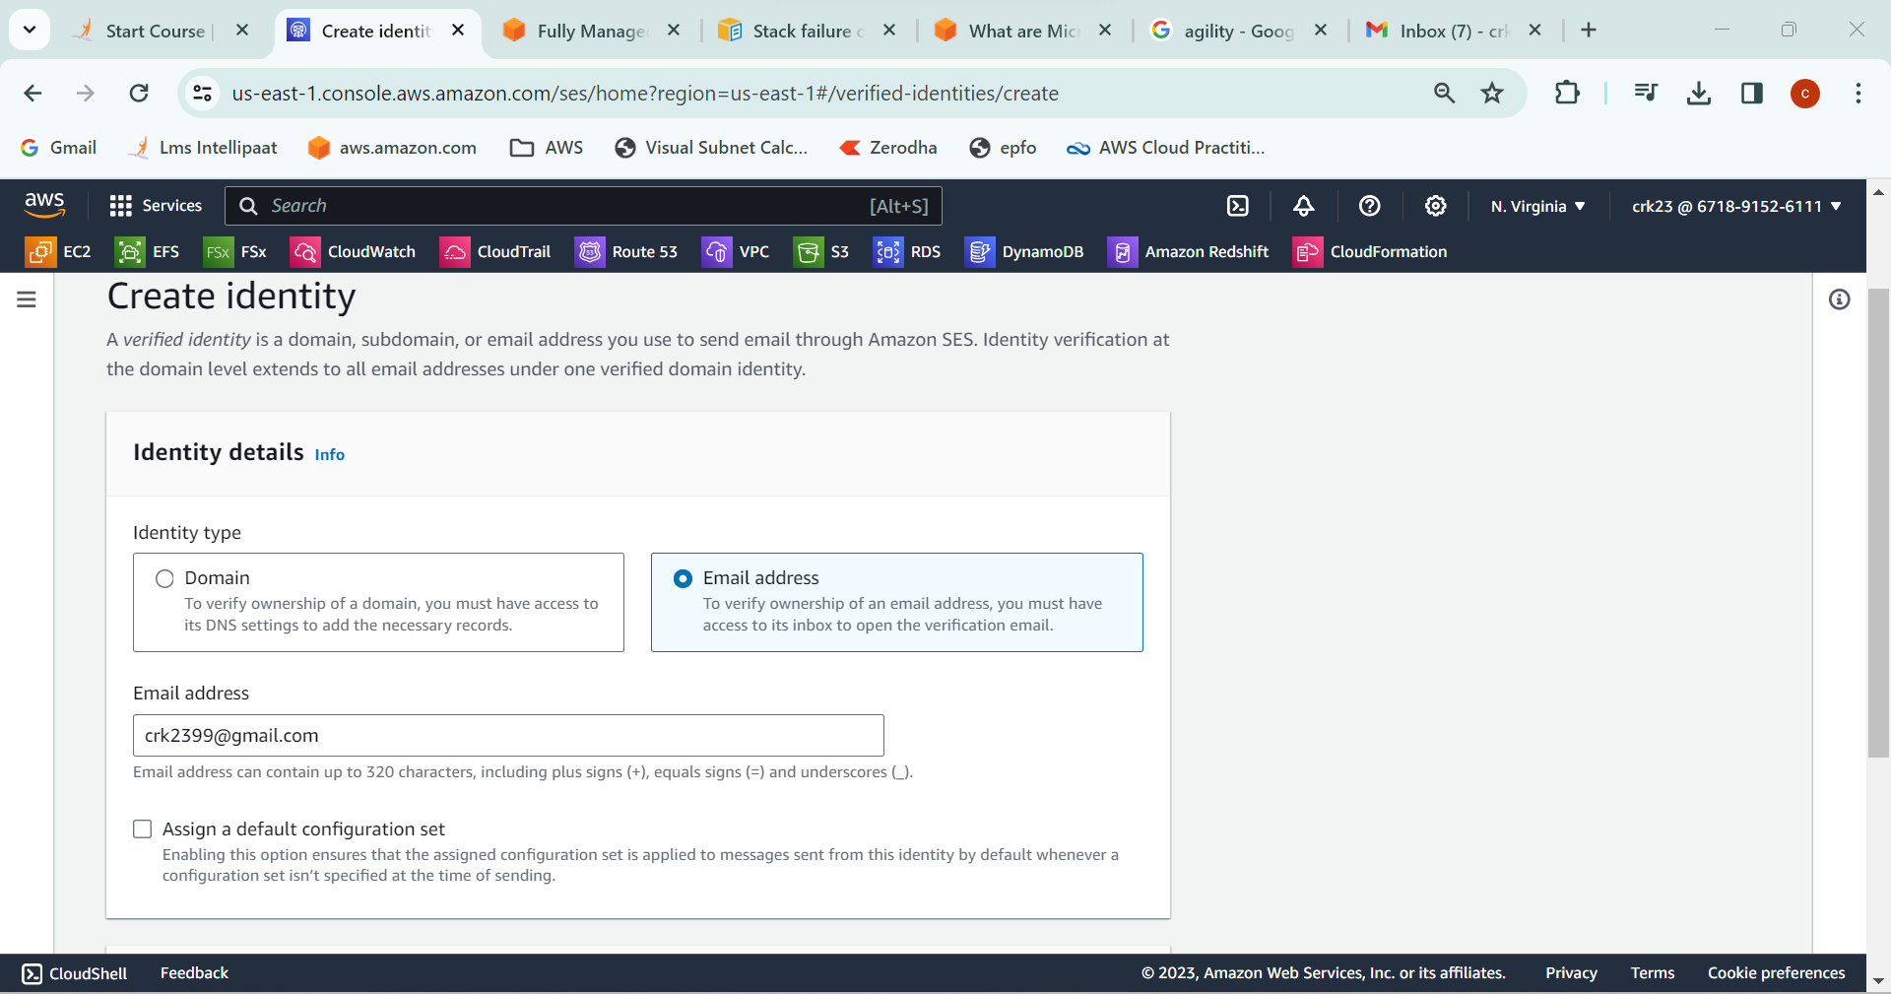

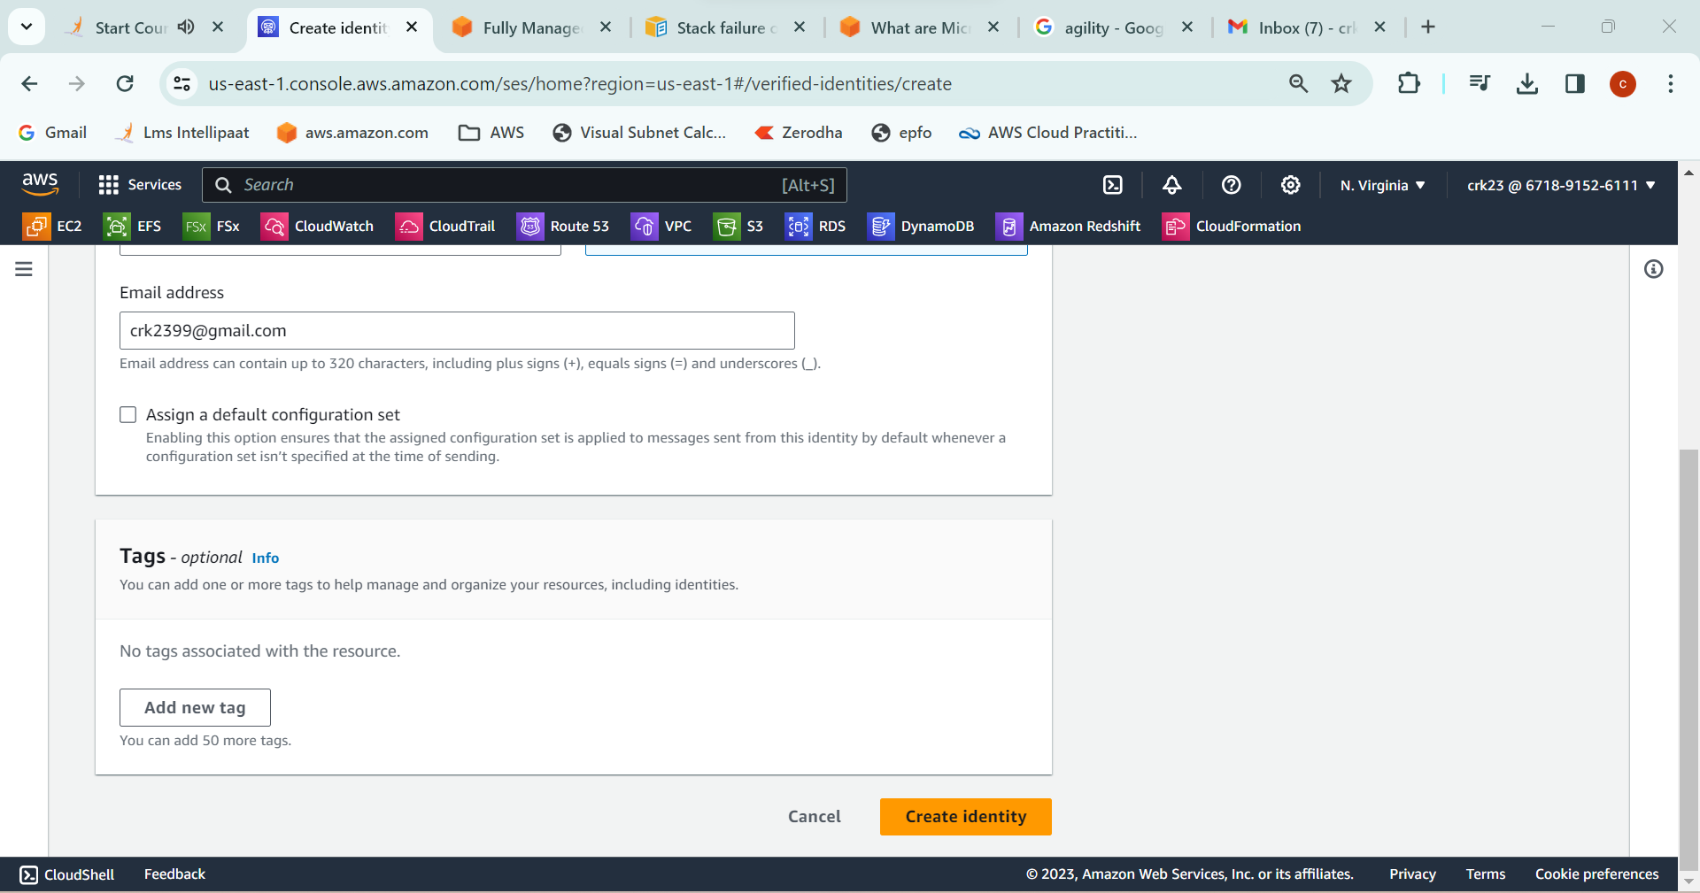

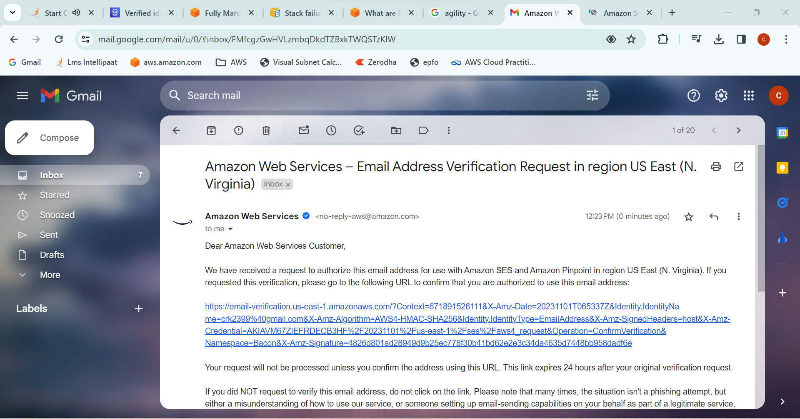

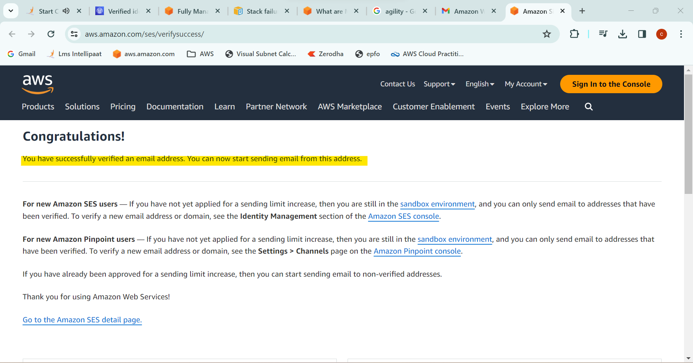

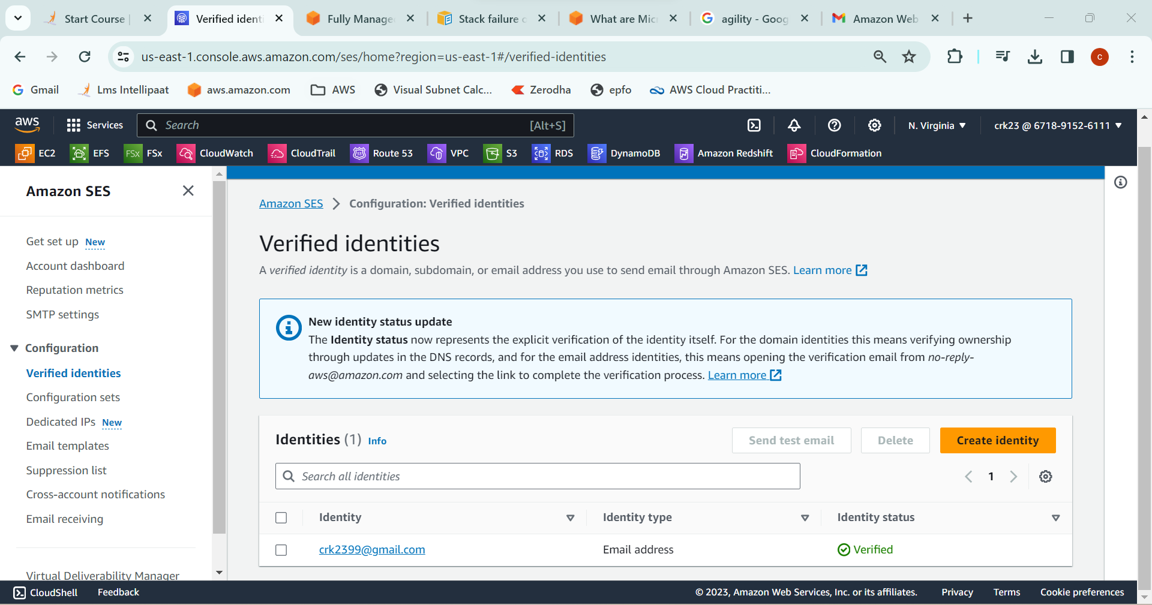

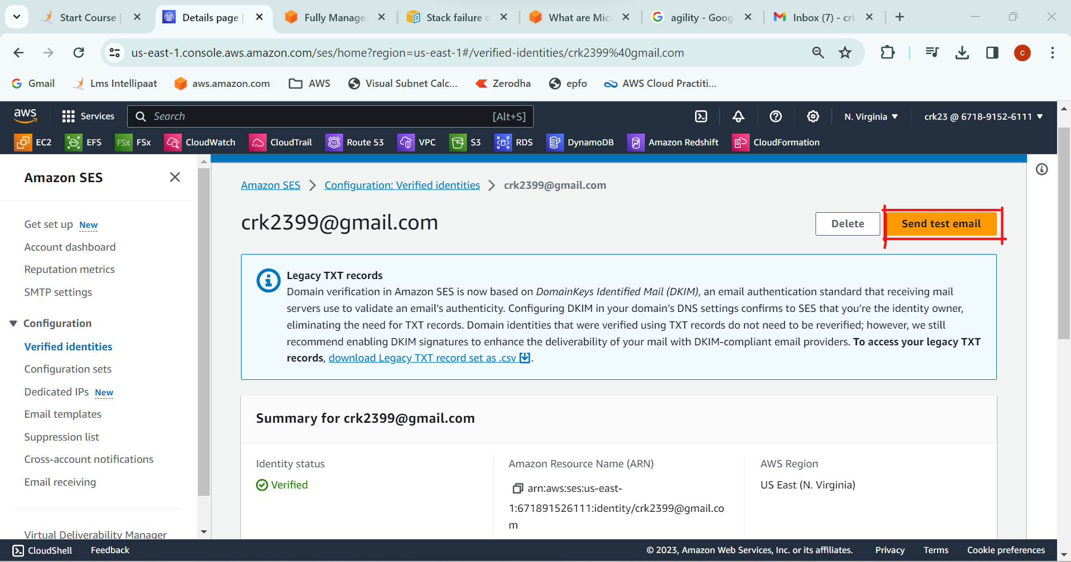

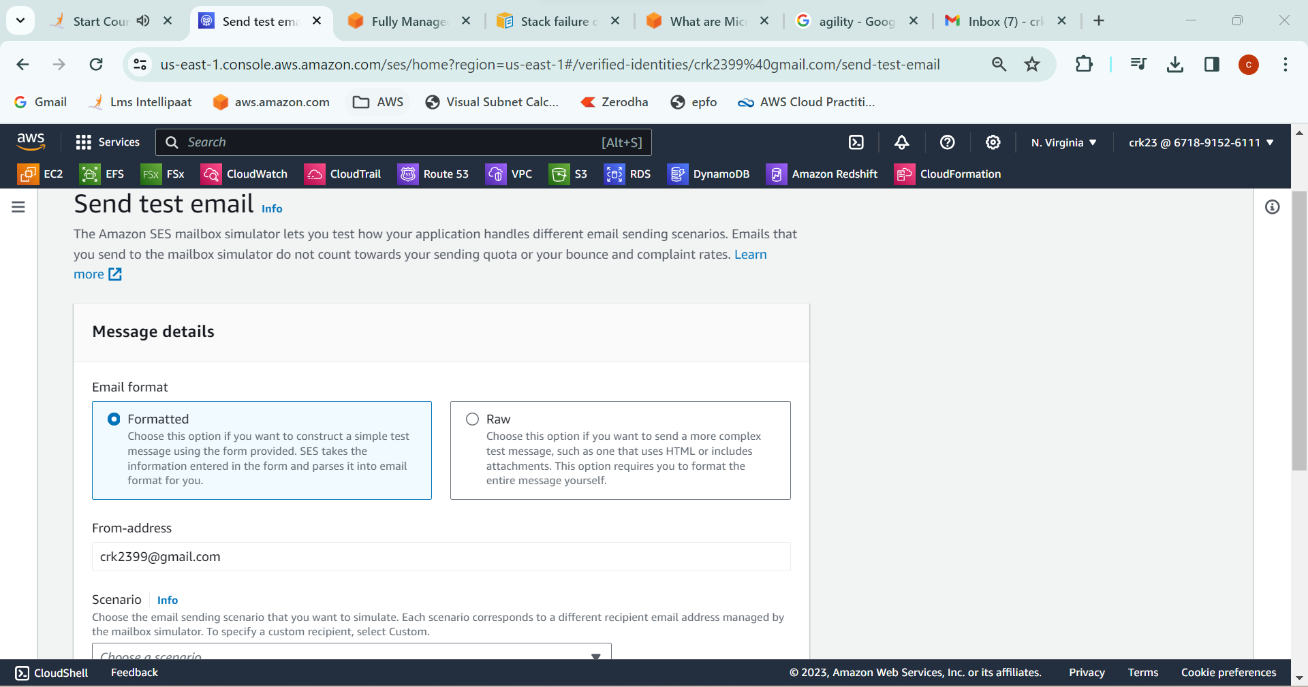

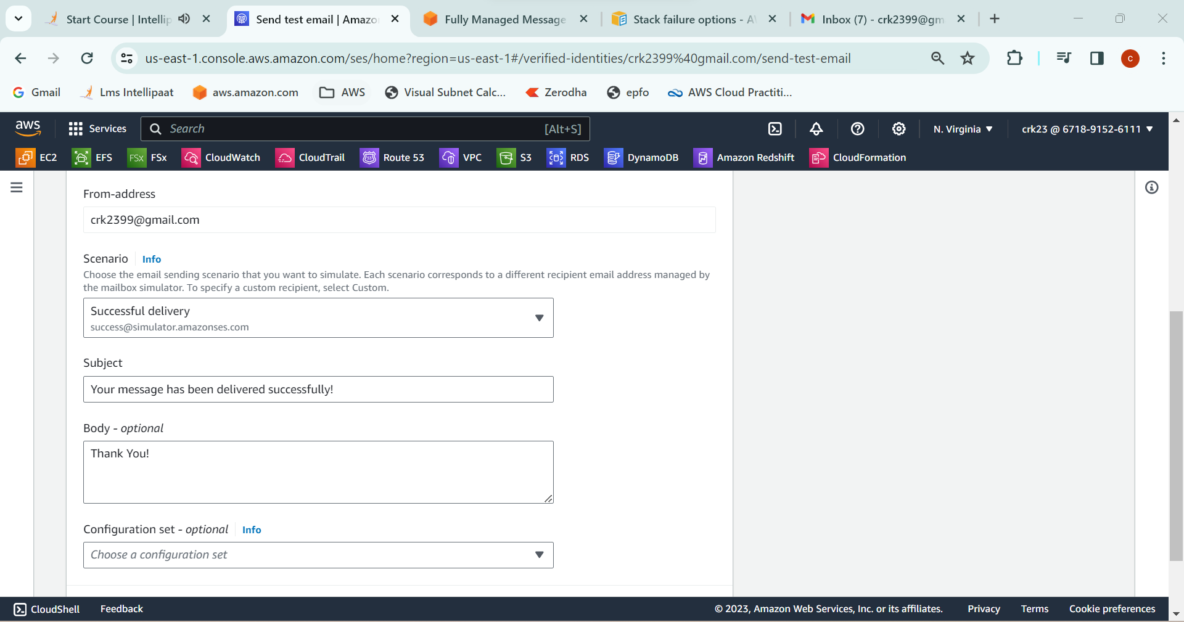

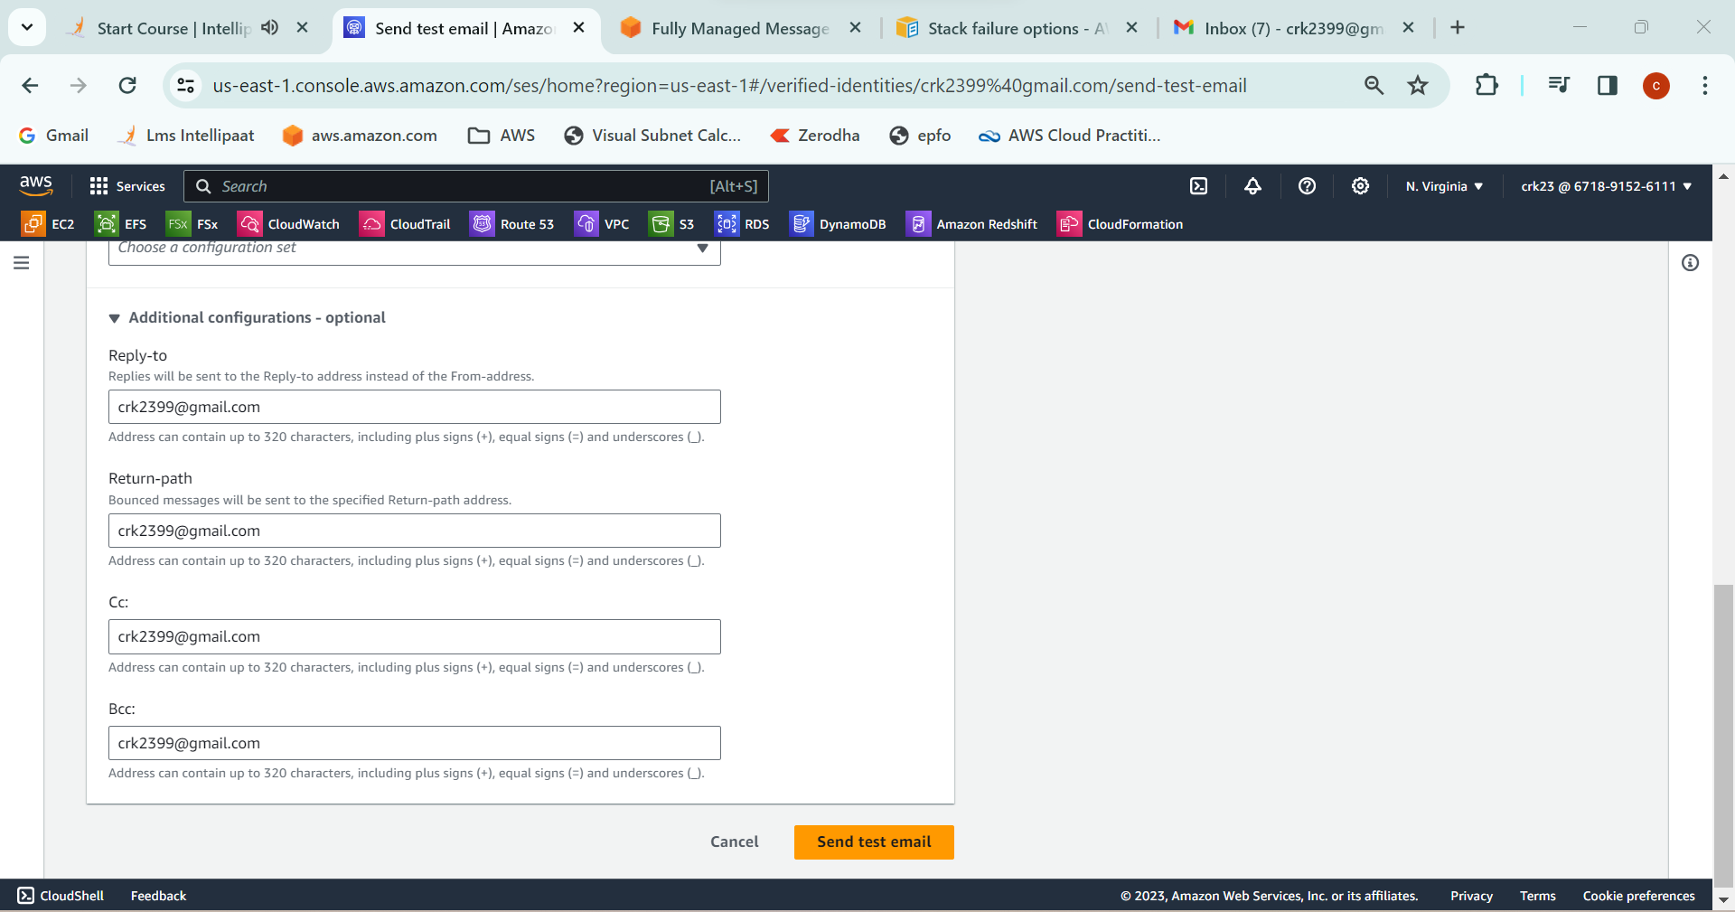

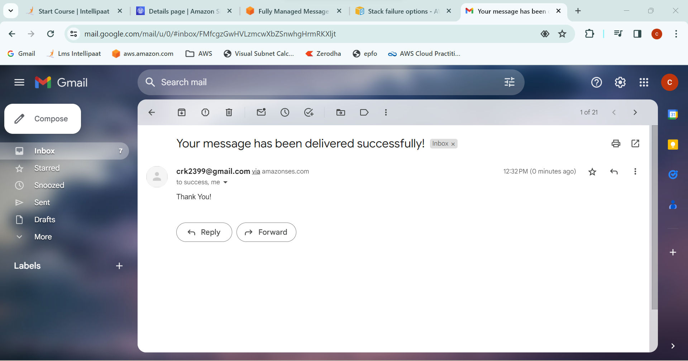

**OUTPUT:**

Created a FIFO SQS queue and tested it by sending messages and Created an identity in SQS and registered my mail id in SES and sent a test mail to check.